

**KABARAK UNIVERSITY**

**SCHOOL OF COMPUTER SCIENCE**

**DEPARTMENT OF COMPUTER SCIENCE AND IT**

**COMP 411:RESEARCH PROJECT 1**

**PROJECT TITLE: PUBLIC CENSUS MANAGEMENT SYSTEM**

**A Research Proposal Submitted to the Board of Graduate Studies in Partial Fulfillment of the Requirements for Conferment of the degree in Computer Security and Forensics.**

**BBIT/MG/1595/09/21**

**EDDY ODUOR**

**PERIOD:JAN-APRIL 2025**

**SUPERVISOR:MR CLEOPHPAS MOCHOGE**

# DECLARATION

I hereby declare that this is my original work and to the best of my knowledge it has not been presented for the award of degree in BBIT in this or any other institution of higher learning.

EDDY ODUOR OWINO

Sign………………. Date………………………..

Mr. CLEOPHAS MOCHOGE

Sign………………. Date………………………..

# ACKNOWLEDGMENT

I would like to express my deepest gratitude to GOD for enabling me to live up to this day, keeping me healthy as I completed this project.First and foremost, I am immensely grateful to Mr. CLEOPHAS MOCHOGE, whose guidance, support, and encouragement were invaluable throughout the project. Your insights and expertise were instrumental in shaping the direction and outcome of this work.I would also like to thank my classmates and friends for their continuous support and for providing a stimulating environment that fostered creativity and collaboration. Your feedback and suggestions were crucial in refining the project.Special thanks to my family for their unwavering support and understanding during the course of this project. Your patience and encouragement kept me motivated and focused.

Thank you all for your contributions and support.

# ABSTRACT

Census taking has a long history that dates back to ancient empires and nations. The practice of collecting data to inform and direct policy has endured over time. In the past, empires and nations took regular censuses to tax people and count men for war through going door to door with pieces of papers to record data, which could easily get lost or ruined. Today, census data is used to inform policy decisions on issues like infrastructure development, military resources, and more.In Kenya today, the census is conducted using mobile technology, where officials go door-to-door, recording information on electronic tablets, which send the data to servers through the use of the Hoji App that is now unsecure and outdated. This method as it was successful will be insufficient today.The Public Census Management System (PCMS) is a comprehensive solution designed to improve the efficiency, accuracy, and transparency of the census process. Conducting a census is a complex and time-consuming task that requires accurate and efficient data collection, processing, and analysis. Traditional census methods often rely on manual data collection, which can lead to errors, delays, and increased costs. To address these challenges, the PCMS leverages technology to streamline the census process, providing a more reliable and efficient way to collect, process, and analyse census data.Overall, by leveraging technology to streamline the census process, the PCMS can help to improve the lives of citizens, and to promote more effective and sustainable development.

CONTENTS

DECLARATION i

ACKNOWLEDGMENT ii

ABSTRACT iii

CHAPTER ONE 1

1.0 INTRODUCTION 1

1.1 BACKGROUND OF STUDY 1

1.2 STATEMENT OF PROBLEM 2

1.3 MAIN OBJECTIVE 3

1.3.1 SPECIFIC OBJECTIVE 3

1.4 RESEARCH QUESTIONS 3

1.5 JUSTIFICATION OF STUDY 3

1.6 SIGNIFICANCE OF THE STUDY 4

1.7 SCOPE AND LIMITATION OF THE STUDY 4

1.7.1SCOPE 4

1.7.2 LIMITATIONS 4

1.8 PROPOSED MODULES 4

CHAPTER TWO 5

LITERATURE REVIEW 5

2.1 INTRODUCTION 5

2.2 REVIEW ON RELATED LITERATURE 5

2.3 REVIEW ON OBJECTIVE 1 7

2.4 REVIEW ON OBJECTIVE 2 7

2.5 REVIEW ON OBJECTIVE 3 7

2.6 REVIEW ON OBJECTIVE 4 7

2.7 CONCEPTUAL FRAMEWORK 7

2.7.1 USER-CENTRED DESIGN 7

2.7.2 MODULAR DESIGN 8

CHAPTER 3 9

RESEARCH, DESIGN, AND METHODOLOGY 9

3.1 INTRODUCTION 9

3.2 RESEARCH DESIGN METHODS 10

3.2.1 DEVELOPMENT METHODOLOGY 10

3.3 DATA COLLECTION INSTRUMENTS 11

3.4.1 SYSTEM ANALYSIS 11

USE CASE DIAGRAM 13

ENTITY-RELATIONSHIP DIAGRAMS (ERDS) 14

DATA FLOW DIAGRAM(DFD) 15

3.4.2 SYSTEM DESIGN 16

3.8 RESEARCH ETHICS 19

CONCLUSION 20

REFERENCES: 21

APPENDICES 22

# LIST OF FIGURES

Figure 1: Concept Map 8

Figure 2: Use Case Diagram 13

Figure 3: Entity Relationship Diagram 14

Figure 4: Data Flow Diagram 15

# CHAPTER ONE

## 1.0 INTRODUCTION

The Public Census Management System is an innovative project aimed at modernizing the way census data is collected, processed, and utilized. Traditional census methods involve extensive paper-based surveys, which are time-consuming, labor-intensive, and prone to errors. The proposed app leverages modern technology to streamline the census process, making it more efficient, accurate, and accessible. By employing a new system, this project seeks to enhance the data collection process, improve the accuracy of demographic data, and provide real-time analytics for better decision-making and policy formulation.

## 1.1 BACKGROUND OF STUDY

Historically, censuses have been conducted at regular intervals to collect data on the population size, distribution, and various socio-economic indicators. This data is vital for overall major planning and development programs. However, the traditional methods have several drawbacks, including high costs, long durations, and the potential for data inaccuracies. (Cassius Dio, 1914)

The public census taking has a rich history that dates back to 1790 in the United States. It is mandated by law and is considered the largest peacetime mobilization effort in the world. The U.S. Census Bureau is responsible for conducting the census every 10 years, with the goal of counting every individual and surveying a percentage of the population to provide a snapshot of the nation's inhabitants. (US Census Bureau, n.d.).

In recent years, countries have continued to conduct censuses to gather vital data on their populations. For example, in 2012, Brazil assisted Senegal with its census, providing state-of-the-art information gathering and processing technologies. In 2019, the Democratic Republic of the Congo began preparations for its second census in history, with the previous census taking place in 1984.

With the proliferation of smartphones and the internet, there is a growing potential to harness these technologies for census data collection. Mobile web applications can offer a user-friendly interface for respondents, real-time data submission, and instant validation of information. This can significantly reduce the time and cost involved in conducting a census while enhancing the accuracy and reliability of the data collected. (Census Bureau, 2020).

The census data collection and processing procedures have also changed over the years. In the past, printed reports were a major method of publication, but with the advent of computer technology, the census data is now published online. The 1960 census was the first to be tabulated completely by computer, and the 1990 census was the first to go online, offering data in PDF format.

The census is a complex operation that involves months and years of planning and strategy, coordinating the efforts of thousands of people and partnerships at various governmental and organizational levels. It is a massive undertaking that generates a plethora of census data products over a span of several years. (Ogot, 1995).

Countries around the world are increasingly adopting digital solutions for census data collection. For example, the United States Census Bureau implemented an online response option for the 2020 Census, which saw significant participation. Similarly, other countries are exploring or have implemented digital solutions to streamline their census operations.

The Kenyan census has relied heavily on involving a large workforce for data collection. Enumerators go door-to-door to collect information on household members, their socio-economic status, and other demographic details. The collected data is then transported to central locations where it is manually entered into databases. This method is labour-intensive, with logistical challenges in reaching remote and inaccessible areas. Additionally, the manual data entry process introduces the risk of errors, leading to potential inaccuracies in the census data. (Kenya National Archives, n.d.).

The 2019 Kenya Population and Housing Census was the first paperless census, where mobile technology was used. The census officials used locally assembled ICT equipment, including tablets running specialized data collection software. The software used was the Hoji mobile app, which was designed to gather the information the government wanted to collect. The enumerators administered an electronic questionnaire using the Hoji mobile app at each household.

## 1.2 STATEMENT OF PROBLEM

The traditional methods of conducting censuses are fraught with challenges, such as, lengthy duration's, and the risk of data inaccuracies due to manual entry errors. Furthermore, the logistics of reaching remote or inaccessible areas can lead to under-reporting and incomplete data, which undermines the reliability of the census results. There is a need for a more efficient, accurate, and cost-effective solution to address these issues.

## 1.3 MAIN OBJECTIVE

The main objective of this study is to develop a system that can streamline the Census taking process making it usable over a large geographical area.

### 1.3.1 SPECIFIC OBJECTIVE

I. To design an intuitive user interface: Creating a user-friendly interface that makes it simple for users to access important data, manage the system, and collect data.   
II. To design systems for ongoing evaluation, input, and changes so that the system adapts to the needs of users and advances in technology.   
III. To design the system as mobile-friendly as possible: Provide a mobile acceptableness of the application so that users can utilize capabilities from any mobile operating system.

IV. To design a secure system that will not leak critical information to outsiders.

## 1.4 RESEARCH QUESTIONS

1. What are the common usability issues faced by users in similar systems, and how can they be mitigated?
2. How can user feedback be systematically collected and analyzed to inform system improvements?
3. How can the system ensure compatibility with various mobile operating systems?
4. What technologies and frameworks are most suitable for building a flexible and secure system?

## 1.5 JUSTIFICATION OF STUDY

The study is justified by the need to modernize the census process, making it more efficient and accurate. By leveraging mobile technology, the proposed app can significantly reduce the costs and logistical challenges associated with traditional census methods. Additionally, real-time data analytics can provide valuable insights for policymakers, leading to more informed decision-making and resource allocation.

## 1.6 SIGNIFICANCE OF THE STUDY

The significance of this study is to design, develop, and evaluate a system for conducting public censuses. This app aims to: simplify the data collection process, improve data accuracy, provide real-time analytics.

By leveraging digital technology, the study seeks to demonstrate the feasibility and benefits of a mobile-based census system compared to traditional methods.

## 1.7 SCOPE AND LIMITATION OF THE STUDY

### 1.7.1SCOPE

Design and development of the web application.

Pilot testing in selected regions.

Evaluation of the app's performance in terms of efficiency, accuracy, and user satisfaction.

### 1.7.2 LIMITATIONS

The study may face challenges related to digital literacy among respondents.

Ensuring data security and privacy will be critical.

There may be resistance to change from stakeholders accustomed to traditional methods.

By addressing these aspects, the Public Census Project aims to demonstrate the potential of digital technology to transform the way census data is collected and utilized, ultimately contributing to more effective governance and development planning.

## 1.8 PROPOSED MODULES

User Interface Module: A user-friendly interface for respondents to input their data.

Data Validation Module: Real-time checks to ensure data accuracy and completeness.

Data Transmission Module: Secure mechanisms for transmitting data to the central server.

Database Module: A robust database to store and manage the collected data.

# CHAPTER TWO

# LITERATURE REVIEW

## 2.1 INTRODUCTION

The literature on public census management systems emphasizes the importance of data quality, effective planning, and the integration of technology to enhance efficiency. The evolution of census management has been significantly influenced by advancements in technology, leading to the development of computer-based systems that streamline data collection and processing.

The key topics discussed include:Data Quality in Census Management – The importance of accurate, reliable, and consistent data for effective policy making. Effective Planning for Census Operations – Strategies for organizing and executing a census, including resource allocation and logistics.Integration of Technology in Census Management – The role of digital tools in enhancing data collection, processing, and analysis. Evolution of Census Management Systems – The shift from traditional paper-based methods to modern, computer-based systems.Efficiency Improvements through Technology – How technological advancements streamline census operations and reduce errors.

## 2.2 REVIEW ON RELATED LITERATURE

The 2019 Kenya Population and Housing Census was the 8th to be conducted in Kenya and the first paperless census, where mobile technology was used during mapping and enumeration. The census was conducted under the provisions of the Constitution of Kenya, 2010, and the Statistics (Amendment) Act, 2019. [3]. The software used was the Hoji mobile app, which was designed to gather the information the government wanted to collect.

As the Hoji App did assist the government to complete its task for collecting Census data the drawbacks that came from using it were: Technical Issues, the app experienced technical issues such as bugs or connectivity problems, which hindered data collection. In limited Internet Access areas, enumerators faced challenges in transmitting data to the central server. Device Compatibility, the app was not be compatible with all devices, which limited its use in certain phones. Data Quality: The app's automated data validation feature did not detect all errors or inconsistencies, requiring additional quality control measures.

The Public Census Management System is a digital platform designed to collect, manage, and analyse census data and improve on the areas that the Hoji App used previously struggled. This new system will have bug fixes. In areas with limited internet access the system will save data locally and uploaded when there is internet access. The new system will be compatible with all android phones. The new system will have a data validation module to reduce errors. Its primary goal is to facilitate the efficient collection of demographic information from the public, ensuring data accuracy and security. The web app is intended to be user-friendly, secure, and capable of handling large datasets.

The advent of digital technology presents an opportunity to transform how census data is collected and managed. A digital platform for census collection not only simplifies the process but also enhances data accuracy, reduces costs, and improves accessibility for diverse populations. The Public Census system aims to leverage these technological advancements to develop a comprehensive, secure, and user-friendly platform for collecting and analysing census data. (Census Bureau, 2020)

The primary objective of the Public Census system is to modernize the census process, ensuring that it is efficient, accurate, and secure. By developing a digital platform, the project aims to streamline data collection, minimize errors, and provide real-time data analysis capabilities. Additionally, the web app will focus on user security, ensuring that personal data is protected and that users are aware of best practices in data security and privacy.

Key features of the web app will include secure user authentication, intuitive data entry forms, robust data management systems, and advanced data visualization tools. The success of the Public Census system depends on its usability and accessibility. The web app will be designed with a user-centric approach, ensuring that it is intuitive and easy to navigate for users of all ages and technical proficiencies. Features such as multilingual support, responsive design, and clear instructions will be incorporated to enhance the user experience.

Given the sensitive nature of census data, ensuring the security and privacy of user information is paramount. The web app will implement advanced security measures, including encryption, secure authentication, and access control, to protect user data. Additionally, it will provide users with information and tips on best practices for maintaining their data security and privacy.

## 2.3 REVIEW ON OBJECTIVE 1

A mobile-friendly system is essential for ensuring accessibility and ease of use, particularly in large-scale census operations. , a responsive design that adapts to different screen sizes ensures that users have a seamless experience, regardless of the device they are using. A well-optimized web application also needs to prioritize performance, ensuring fast loading times and minimal battery consumption for efficiency in the field.

## 2.4 REVIEW ON OBJECTIVE 2

To further enhance mobile usability, incorporating offline functionality is crucial, especially in remote areas with limited internet connectivity. An offline mode with auto-sync capabilities allows census workers to collect data without interruptions, ensuring a smooth workflow even in challenging environments. By focusing on these factors, the mobile-friendly system will not only expand accessibility but also streamline the data collection process, making it more efficient and inclusive.

## 2.5 REVIEW ON OBJECTIVE 3

On the other hand, data security is a fundamental requirement for any census management system, as it involves handling sensitive personal information. To prevent unauthorized access and data leaks, implementing end-to-end encryption is necessary to secure data during transmission and storage.

## 2.6 REVIEW ON OBJECTIVE 4

Additionally, multi-factor authentication (MFA) can strengthen access control by requiring multiple verificatio5n steps, significantly reducing the risk of unauthorized logins. Role-Based Access Control (RBAC) should also be employed, ensuring that only authorized personnel have access to specific datasets based on their responsibilities.

## 2.7 CONCEPTUAL FRAMEWORK

### 2.7.1 USER-CENTRED DESIGN

keeping end users' requirements and preferences in mind at every stage of the design and development process. This entails carrying out persona development, user research, and usability testing.

### 2.7.2 MODULAR DESIGN

applying a modular design methodology to aid in maintenance and scalability. Space allocation, real-time tracking, and analytics are a few examples of modules that are designed separately but incorporated into the system as a whole.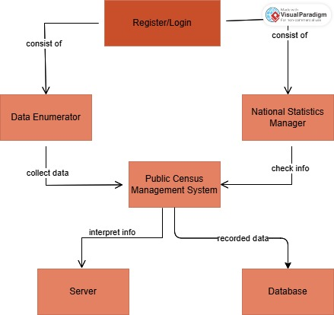

Figure 1: Concept Map

# CHAPTER 3

# RESEARCH, DESIGN, AND METHODOLOGY

## 3.1 INTRODUCTION

The research methodology is a critical component of the study, providing a structured approach to investigating the complexities of public census management systems. By carefully selecting research designs, data collection methods, and analytical techniques, I can ensure that the findings are robust, reliable, and contribute valuable insights to the field. This methodological rigor not only enhances the credibility of the research but also informs best practices for future census initiatives.

**LOCATION OF THE STUDY**

National Level and Regional Level. Conducting the study at the national level, covering the entire country. It provides a comprehensive understanding of the census management system at the national level. Regional by conducting the study at the regional level, focusing on a specific geographic region such as a province, county or city which allows for a more in-depth study of the census management system in a specific region.

**POPULATION OF THE STUDY**

Entire Country: The population of the entire country, including all citizens and residents. All age groups (0-100+), with a focus on adults (18+). Gender: Male, female, and non-binary individuals. Ethnicity of diverse ethnic backgrounds.

**SAMPLING PROCEDURE AND SAMPLE SIZE**

Convenience Sampling: Participants are selected based on their availability and accessibility. Purposive Sampling: Participants are selected based on their expertise or knowledge related to the study. Snowball Sampling: Participants are selected based on referrals from other participants.

The sample size depends on several factors, including: Population size: The larger the population, the larger the sample size required. Desired level of precision: The higher the desired level of precision, the larger the sample size required.

## 3.2 RESEARCH DESIGN METHODS

Qualitative Methods by Conducting interviews with stakeholders (e.g., government officials, citizens, data analysts) and perform focus groups to gather insights on user needs and system requirements. There after analyse qualitative data to identify common themes and issues. And QuantitativeMethodsby designing surveys to collect data from a large sample of the population. Use statistical methods to analyse survey results.

## 3.2.1 DEVELOPMENT METHODOLOGY

**Development Approach**

For the development of the Public Census Management System, we will follow the Agile methodology. Agile is well-suited for this project because it allows for incremental development, continuous feedback, and flexibility in accommodating evolving requirements. Since the system involves multiple components, including data collection, mobile accessibility, security measures, and user interface design, Agile ensures that features can be developed and tested in small, manageable cycles.

The justification for choosing Agile includes:

Project Complexity: The system involves various stakeholders (e.g., government agencies, field data collectors, and data analysts), each with unique needs that may evolve over time. Agile’s iterative approach helps in integrating feedback from all users.

Scalability & Flexibility: Agile allows us to build a minimum viable product (MVP) first, then expand functionality in later iterations, ensuring the system remains adaptable.

Faster Delivery: Agile ensures that functional components of the system are delivered in phases, allowing partial deployment and testing before full implementation.

**Iterative Processes**

Sprint 1: System Requirements & Initial Design

Sprint 2: Core System Development

Sprint 3: Security Implementation

Sprint 4: Testing and Optimization

Sprint 5: Deployment & Monitoring

## 3.3 DATA COLLECTION INSTRUMENTS

Surveys: Online Surveys: Conduct online surveys using tools like Google Forms, SurveyMonkey, or Type form.

Interviews: In-Depth Interviews: Conduct in-depth interviews with key stakeholders, such as census officials, community leaders, or business owners.

Secondary Data Collection: Literature Review: Conduct a literature review of existing research on census management systems. Government Reports: Collect data from government reports, such as census data or policy documents. Online Data Sources: Collect data from online sources, such as websites, social media, or online databases.

## 3.4.1 SYSTEM ANALYSIS

Where it involves examining the functional and non-functional requirements, understanding system constraints, and ensuring feasibility. It provides the foundation for designing and implementing an effective solution.

**Requirements Gathering**

To build a system that meets the expectations of all stakeholders, multiple data collection methods are used:

Interviews: Conduct discussions with government officials, census administrators, and data collectors to understand their needs.

Surveys and Questionnaires: Collect feedback from field workers and system users to identify key challenges in the current census process.

Observation: Monitor existing census data collection and processing methods to detect inefficiencies.

**Requirements Analysis**

Once data is collected, the system requirements are analyzed and categorized:

**Functional Requirements:**

The system must allow secure data collection..

It should support offline data collection with automatic synchronization.

Users should be able to generate real-time reports and analytics.

**Non-Functional Requirements:**

The system should ensure high performance and scalability to handle large datasets.

It must comply with data security regulations such as GDPR and HIPAA.

The user interface should be intuitive for both field workers and administrators.

**Use Cases:**

Example: A census officer logs into the system, collects household data using a mobile device, and uploads it when an internet connection is available.

**User Stories:**

Example: "As a census administrator, I want to generate a demographic report so that I can analyze population trends."

**Feasibility Study**

**Technical Feasibility:**

The system will use cloud-based storage for scalability and security.

It will support mobile and web platforms for accessibility.

**Economic Feasibility:**

The system will reduce paper-based costs and manual labor expenses.

Open-source tools will be used to minimize software costs.

**Operational Feasibility:**

The system will integrate smoothly into the existing government census infrastructure.

Training programs will be provided for field agents and administrators.

**System Modeling**

To visualize how the system operates, various modeling techniques are used:

## USE CASE DIAGRAM

Illustrate how census data is collected, processed, and stored.

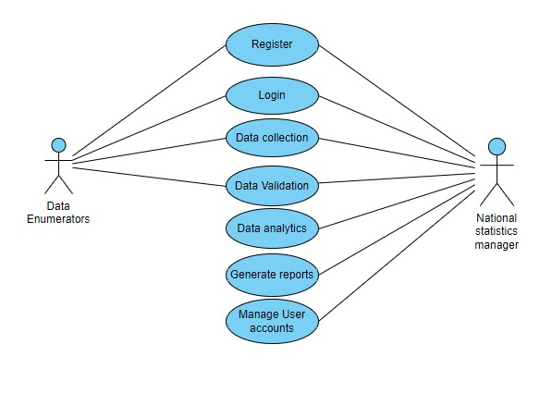

Figure : Use Case Diagram

## 

## ENTITY-RELATIONSHIP DIAGRAMS (ERDS)

Define relationships between entities like census , household, person and address.

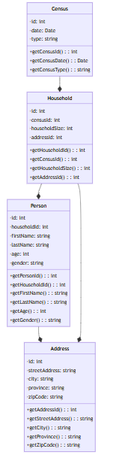

Figure 3: Entity Relationship Diagram

## DATA FLOW DIAGRAM(DFD)

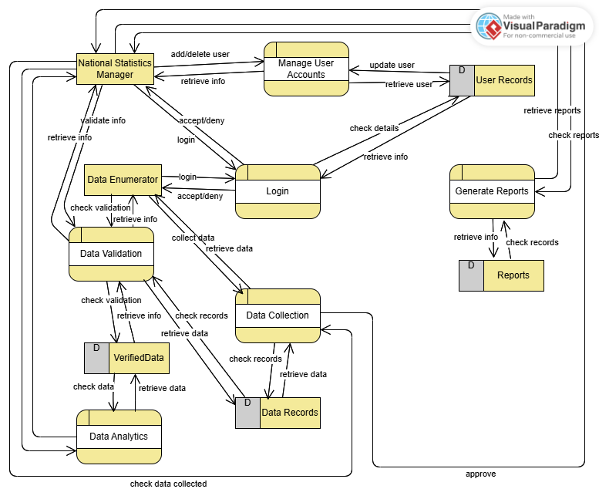

Figure 4: Data Flow Diagram

## 3.4.2 SYSTEM DESIGN

The System Design phase follows System Analysis and focuses on the technical structure, architecture, and implementation of the Public Census Management System. It ensures that the system is well-structured, scalable, and efficient while meeting the project’s functional and non-functional requirements. Below is a breakdown of key components of system design.

**Architectural Design**

**System Architecture**

The Public Census Management System follows a three-tier architecture, consisting of:

Presentation Layer (Frontend):

Web applications for data collection and report generation.

Built using React to ensure a seamless user experience.

Business Logic Layer (Backend):

Handles data processing, validation, and security enforcement.

Developed using Node.js with Express.js for API management.

Data Access Layer (Database):

Stores census data securely.

Uses PostgreSQL for structured data and MongoDB for flexible storage of dynamic data.

**Layered Architecture**

The system follows a layered approach to ensure modularity and maintainability:

Presentation Layer: Handles user interactions via mobile/web interfaces.

Business Logic Layer: Processes census data, applies validation rules, and manages role-based access.

Data Access Layer: Manages data storage, retrieval, and database security.

**Detailed Design**

**Component Design**

The system is broken into several independent modules, including:

User Management: Handles authentication, authorization, and role-based access control (RBAC).

Data Collection Module: Supports real-time and offline data entry, with auto-sync when an internet connection is available.

Security Module: Implements encryption (AES-256), multi-factor authentication (MFA), and audit logs.

Reporting and Analytics: Generates demographic reports, graphs, and trends for policymakers.

**Database Design**

The system uses PostgreSQL for structured data and MongoDB for unstructured or flexible data storage.

Database Schema Example:

Tables:

Person (PersonID, Name, Email, Age, Gender,PasswordHash)

CensusData (RecordID, UserID, Location, HouseholdSize, Date)

Household (HouseID, CensusData,HouseHoldSize,Address)

Address(AddressID, County, SubCounty, Street)

User Interface (UI) Design

The UI is designed for simplicity and efficiency to accommodate field agents and administrators.

**Design Approach:**

Web Dashboard: Provides a graphical overview of census data, reports, and user management tools.

Web Mobile Application: Offers a simplified form-based interface for quick and error-free data entry.

Wireframes & Mockups: Created using Figma or Adobe XD to visualize the user flow.

**Prototyping**

**Low-Fidelity Prototypes:**

Sketches or wireframes are created to outline UI layouts, navigation, and workflows.

Tools like Canva are used for quick design visualization.

**High-Fidelity Prototypes:**

Interactive UI models are developed in Figma or Adobe XD to simulate user interactions before full development.

Allows stakeholder testing and feedback incorporation before final implementation.

**Design Specification**

Technical Specifications

Frontend Technologies: React

Backend Technologies: Node.js with Express.js.

Database Management: MySQL & MongoDB.

**Design Documents**

System Architecture Diagram: Illustrates the interactions between UI, backend, and database.

Data Flow Diagrams (DFD): Shows how data moves from collection points to storage and reporting.

Entity-Relationship Diagrams (ERD): Defines database relationships and constraints.

**Review and Validation**

**Design Review**

Conducted with stakeholders (government agencies, census officials, and IT team) to ensure the system meets project goals. Feedback is collected and incorporated into refinements.

**Validation**

The design is tested against functional and non-functional requirements to ensure accuracy, efficiency, and security.

## 3.8 RESEARCH ETHICS

Ethical considerations are paramount in any research endeavor, particularly in studies involving public census management systems. Research must navigate various ethical issues to ensure the integrity of the work and the protection of participants' rights. Below are some key ethical issues:

1. Informed Consent

Research must ensure that consent is obtained voluntarily and without coercion. Special attention should be given to vulnerable populations who may have difficulty understanding the consent process.

2. Privacy and Confidentiality

Research must implement measures to safeguard participants' data, such as anonymizing responses, securely storing data, and limiting access to authorized personnel. Clear communication about how data will be used and shared is essential.

3. Data Security

Research should use secure data storage methods, encryption, and secure transmission protocols to protect sensitive information. Regular audits and updates to security measures may also be necessary.

4. Transparency and Honesty

This includes accurately reporting data, avoiding fabrication or falsification of results, and disclosing any funding sources or affiliations that may influence the research.

## CONCLUSION

The Public Census Management System is a comprehensive system designed to manage the entire census process, from data collection to data analysis and reporting. The system is designed to be user-friendly, efficient, and secure, with features such as data validation, data encryption, and access controls.

Benefits of the Public Census Management System over the Previous Hoji App that was used are: Efficiency: Automating the data collection and validation processes to reduce manual effort and errors. Accuracy: Implementing robust validation and processing mechanisms to ensure high-quality and reliable data. Scalability: Designing the system to handle large volumes of data and a high number of concurrent users, making it suitable for nationwide deployment. Security: incorporating strong security measures to protect sensitive census data from unauthorized access and breaches. Usability: Developing user-friendly interfaces for both mobile applications and web portals to facilitate easy data entry and management. Reporting and Analysis: Providing powerful reporting and analytical tools to generate insights and support decision-making.

This system will be pivotal in modernizing the way census data is collected, managed, and analysed. By leveraging advanced technologies and methodologies, this system aims to provide accurate and timely data that can significantly aid in policy-making, resource allocation, and various socio-economic planning efforts. The successful implementation of this project will result in a more efficient, reliable, and secure census process, ultimately contributing to better governance and improved public services.

# REFERENCES:

Kenya. Central Bureau of Statistics. (1994). *Kenya Population Census, 1989* (Vol. 1). The Bureau.

Leete, R. (2001, August). Population and housing censuses: A funding crisis. In *Symposium on global review of 2000 round of population and housing censuses: Mid-decade assessment and future prospects*.

Musyoka, J. M., Macharia, S., Ratemo, C. M., & Kamau, G. W. (2023). Record Management Practices and Service Delivery in Devolved System of Governance of Mavoko Sub-County, Machakos County Kenya.

Nourolahi, T., Ghaemi, Z., Goodarzi, H. M., Naeneeni, O., Jafari, S., Ghaderi, S., ... & Tadaion, P. (2011). 1390 national census of population and housing. *Statistical Center of Iran*.

Ruggles, S., & Magnuson, D. L. (2020). Census technology, politics, and institutional change, 1790–2020. *Journal of American History*, *107*(1), 19-51.

Ruggles, S., & Magnuson, D. L. (2020). Census technology, politics, and institutional change, 1790–2020. *Journal of American History*, *107*(1), 19-51.

Reid-Green, K. S. (1989). The history of census tabulation. *Scientific American*, *260*(2), 98-103.

Statistics, K. N. B. O. (2019). The 2009 Kenya population and housing census. *Nairobi: Kenya National Bureau of Statistics*.

# APPENDICES

**Appendix 1: Gantt chart**

|  |  |  |  |  |  |  |  |  |  |  |
| --- | --- | --- | --- | --- | --- | --- | --- | --- | --- | --- |
| No | Activity | Jan | | Feb | | March | |  | April | |
| 1. | Project proposal approval |  |  |  |  |  |  |  |  |  |
| 2. | Chapter 1 presentation: Introduction |  |  |  |  |  |  |  |  |  |
| 3. | Chapter 2  Presentation: Literature Review |  |  |  |  |  |  |  |  |  |
| 4. | Chapter 3 presentation: Research Design and Methodology |  |  |  |  |  |  |  |  |  |
| 5. | Documentation &  Presentation |  |  |  |  |  |  |  |  |  |

**Appendix 2: Budget**

|  |  |
| --- | --- |
| Item | Cost |
| Internet | Ksh.1000 |
| Printing | Ksh.290 |
| Total | Ksh.1290 |